Project Development Phase
Performance Test

Date | 15 February 2026
Team ID | LTVIP2026TMIDS24256
Project Name | Project - Heritage Treasures: An In-Depth Analysis Of UNESCO World Heritage Sites In Tableau
Maximum Marks

Model Performance Testing:
Project team shall fill the following information in model performance testing template.
S.No. | Parameter | Screenshot / Values
 | Data Rendered | UNESCO World Heritage dataset successfully loaded into Tableau. Dataset includes fields such as Site Name, Country, Continent, Category (Cultural/Natural/Mixed), Year of Inscription, Area (Hectares), Latitude & Longitude, and Danger Status. Total records rendered: 1100+ heritage sites (as per dataset). Data displayed correctly across all visualizations without performance issues.
 | Data Preprocessing | - Removed duplicate entries  - Handled missing/null values in Area and Year fields  - Standardized country and continent names  - Converted Year into Date format  - Created hierarchy (Continent → Country → Site Name)  - Verified data consistency with official UNESCO dataset
3. | Utilization of Filters | - Continent Filter  - Country Filter  - Category Filter (Cultural/Natural/Mixed)  - Year Range Filter  - Danger Status Filter  - Interactive dashboard-level filters applied across multiple sheets 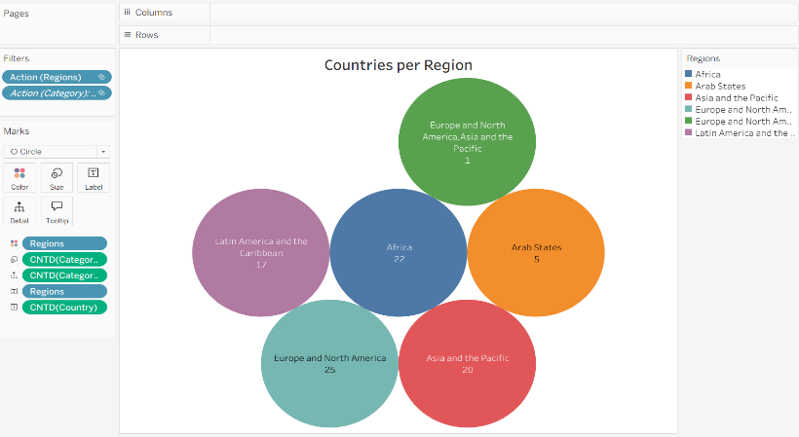
4. | Calculation fields Used | - Total Heritage Sites per Country  - Percentage Distribution by Category  - Year-wise Growth of Sites  - Sites in Danger Count  - Ranking Countries by Number of Sites  - Decade-wise Site Addition Analysis  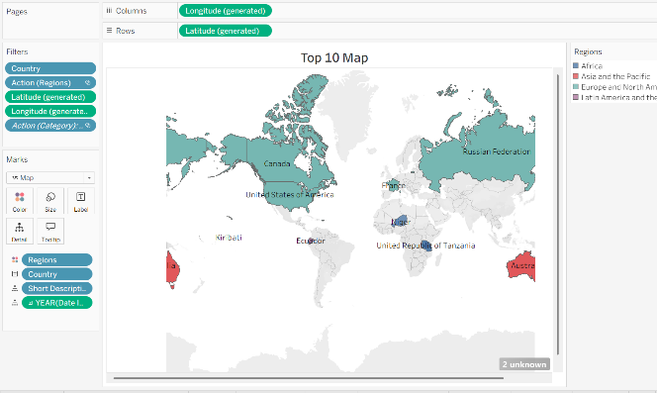
5. | Dashboard design | No of Visualizations / Graphs – 8  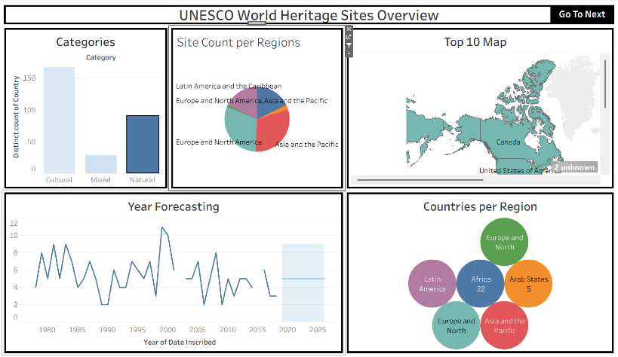
6 | Story Design | No of Visualizations / Graphs – 2  